# Why Did Freight Rates Spike? Ocean Freight in H1 2026 and the H2 Outlook

*Written based on analysis by Samsung SDS Logistics Experts (Logistics MI Group).*

Ocean freight rates ran strong throughout H1 2026. An early peak season arrived sooner and stronger than expected, and geopolitical disruptions kept supply tight at the same time. Will that trend continue in H2? Here's the H1 review, followed by the H2 outlook.

## H1 Trend: Demand — Front-Loading Drove an Early Peak Season

Front-loading amid Middle East risks, higher fuel costs, and tariff uncertainty drove an early peak season. Stronger Asia-origin cargo offset weaker Middle East demand, widening the regional demand divergence.

By the numbers: China-origin container volumes on major routes grew 721k TEU (+6.6% YoY) from January to May 2026. North Europe led that growth at +454k TEU (+12.0%), boosted by early shipments amid geopolitical uncertainty. Middle East volumes fell 250k TEU (-16.7%) over the same period.

Meanwhile, ECSA (East Coast South America) volumes were supported by Chinese vehicle exports and shipments made ahead of Brazil's July EV tariff.

Bottom line: even as Middle East volume dropped sharply, stronger non-Middle East demand — especially into North Europe — offset the decline and kept global demand resilient.

## H1 Trend: Supply — Hormuz Closure and Red Sea Diversions Tightened Capacity

The Hormuz closure sharply reduced Middle East transits, while persistent Red Sea risks kept Suez transits subdued.

On top of that, slower sailing, congestion at major transshipment ports, schedule delays, and capacity reallocation all combined to keep effective capacity tight throughout H1. Even with underlying supply growth, these operational disruptions constrained the capacity actually available to the market.

## H1 Trend: Rates — From War Outbreak to Ceasefire, Rates Stayed Elevated

Freight rates strengthened in H1 on front-loading and Middle East supply disruptions. The U.S.-Iran conflict lifted rates across all trade lanes, with front-loading accelerating the early peak season.

Following the timeline: rates turned upward at the U.S.-Iran war outbreak. Oil prices then peaked and EBS/EFS (Emergency Bunker Surcharge / Emergency Fuel Surcharge) were introduced. Pre-holiday shipping ahead of May added further momentum as the early peak season took hold. A U.S.-Iran ceasefire deal followed, but 3Q fuel surcharge hikes and continued front-loading kept rates elevated through the end of H1.

## H2 Outlook: Demand — Resilient, But Set to Soften

Global container demand is expected to remain resilient this year, supported by solid non-Middle East demand — global container volumes are projected to grow 3.3% YoY in 2026.

But 2H is a different story. Demand is expected to slow markedly from 1H as front-loading limits further growth after the early peak season. An inventory drawdown is expected in 2H, and U.S. import volumes are expected to decline after the July peak — from 2.47m TEU in July down to 1.92m TEU by November.

High inflation and interest rates add further downside risk. Rate hikes in Europe and Japan in June signal that Korea and the U.S. may follow, and prolonged high rates remain a downside risk for consumer-driven cargo.

One potential upside: Middle East trade recovery. Service normalization could support direct Middle East trade, though a gradual recovery is expected to limit near-term volume gains.

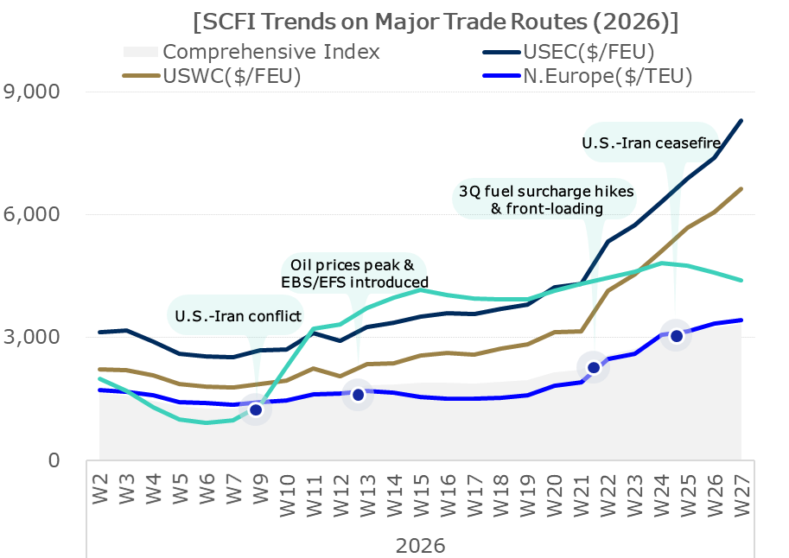

## H2 Outlook: Supply — Newbuild Deliveries Add Pressure

Supply is expected to remain above demand in 2026, with 2H deliveries and capacity recovery adding pressure. Global supply growth is projected at 4.6%, exceeding demand growth (3.3%) by more than 1 percentage point.

Only 45% of newbuilds were delivered in H1, leaving more deliveries for H2. Capacity recovery from easing Middle East risks may add further supply pressure on top of that.

The longer-term picture is more pronounced: the containership orderbook reached 12.91m TEU in June 2026, the highest level since 2010 — equal to roughly 38% of the existing fleet. Newbuild deliveries are projected to climb from 1.57m TEU in 2026 to 3.06m TEU in 2027 and 4.89m TEU in 2028, deepening oversupply and extending downward pressure on rates.

## H2 Outlook: Rates — Firm Through Early 3Q, Then Weaker in 4Q

Freight rates are expected to remain firm through early 3Q on fuel surcharges and front-loading, then weaken in 4Q as costs ease, supply recovers, and demand slows.

**Key drivers in 3Q**: Higher fuel surcharges and potential U.S. tariffs (after July 24) may support continued front-loading. At the same time, fleet redeployment and schedule delays tied to a delayed Gulf recovery may limit effective capacity in the near term.

**Key drivers in 4Q**: Lower oil and bunker prices are expected to reduce fuel surcharges. Gradual service and capacity recovery following the Hormuz reopening should also weigh on rates. And demand is likely to soften further as inventory drawdown, inflation, and the off-season all set in.

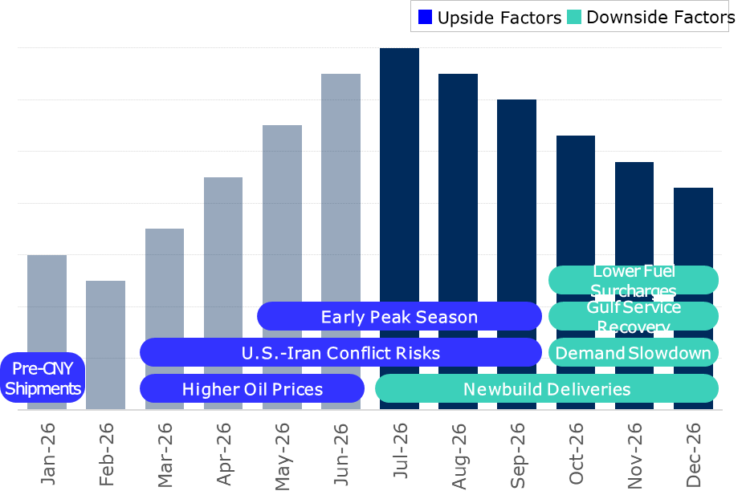

## The Bottom Line

Ocean freight in 2026 tells a story of two very different halves. H1 was shaped by front-loaded demand and geopolitically constrained supply — a combination that pushed rates higher across every trade lane. H2 flips that structure: front-loading and delayed Gulf recovery should keep rates firm through early 3Q, but lower fuel surcharges, Hormuz normalization, and softening demand are set to converge in 4Q and push rates lower.

The specific variables that will determine how this plays out — the pace of oil price normalization, Strait of Hormuz transit and congestion data, and route-by-route fuel surcharge forecasts — are covered with full figures in the complete report.

**This summary is drawn from the [H1 2026 Logistics Market Review & H2 Outlook] — see the full report for the complete picture →**

